State of the Art: Plasma Propagation in Micro-Capillaries
Effects of the tube diameter on the propagation of helium plasma plume via electric field measurement
Reference: Jiangsu_2016_Wu_diameter on the propagation
Atmospheric-pressure helium plasma plume, ignited by a positive pulsed direct current voltage with a pulse rising time of 60ns.
The plasma plume in the open air can be extended to as long as 10cm or longer.
According to the experimental and simulated results,8–12 with the decrease in the tube diameter from several mm to tens of um, the ignition voltage, length of plasma plume, propagation velocity, plasma density, and excitation temperature of helium increase while the gas temperature of the plasma plume remains almost constant.
decreasing tube diameter was accompanied by a fixed gas flow rate in the previous works,
Therefore, the influence of the tube diameter on the properties of APPJs remains ambiguous without the consideration of the associated effects of gas components. To minimize the impact of ambient air, one possible method is confining plasma plumes inside the tubes.
They observed that the plasma plume with smaller aperture has higher discharge current density and ignition voltage.
The aim of this work is to clarify the effects of tube diameter in the range of 0.07–4mm on the length of plasma plume, propagation velocity, electric field in the streamer head, and propagation mode transition.

Experimental setup and methods
Five quartz tubes with a series of inner diameters (ID) of 0.07mm, 0.6mm, 1mm, 2mm, and 4mm are used for this study. The wall thicknesses of the five tubes are 0.15mm for ID¼0.07mm, 2mm for ID¼0.6mm, and 0.5mm for the others.
Helium gas with purity of 99.999% is fed into the tube, and the gas flow rate controlled by the mass flow meter (MKS M100B) is fixed at 1l/min throughout this paper. To prevent the ambient air contamination, a 2m long flexible tube is connected to the right end of the tube.
The exposure time of ICCD is fixed at 40ns, and each fast ICCD image is the integrated picture of 106 shots with the same delay time corresponding to the pulse rising edge of applied voltage. ICCD is triggered by the delay pulse from the signal generator (Tektronix AFG3102C) and synchronized with the voltage pulse.
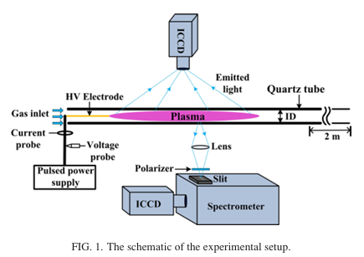

Results
The discharge current was obtained by subtracting the displacement current from the total current. Two discharge current pulses within a positive voltage pulse were observed Rising and Falling edge of the voltage pulse.
The second discharge is generally considered to be related to the residual charges left from the first discharge.
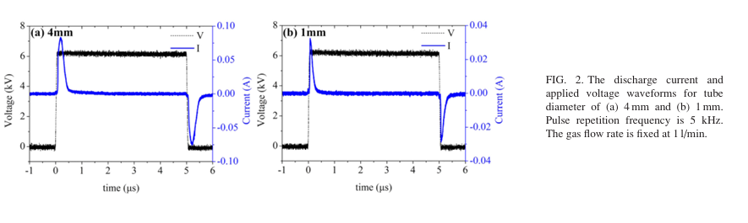

Plume length

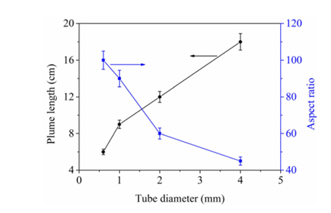
We showed that the dependence of the length and the aspect ratio of plasma plume on the tube diameter.

